NE6101034 AI碩一 柳譯筑

**MATLAB Project of Chapter 2**

1. **Write a MATLAB program to generate a discrete-time exponential signal. Use this function to plot the exponential x[n]=(0.9)^n over the range n=0, 1, 2, …, 20.**

***Code***

Main.m

% matlab’s index starts from 1, so I set i from 1 to 21

for i=1:21

x(i)=0.9^(i-1);

end

x

***Result***

**x = 1.0000 0.9000 0.8100 0.7290 0.6561 0.5905 0.5314 0.4783 0.4305 0.3874 0.3487 0.3138 0.2824 0.2542 0.2288 0.2059 0.1853 0.1668 0.1501 0.1351 0.1216**

**2. Given a differential equation: 𝑦[𝑛] − 1.8 cos ( 𝜋/16) 𝑦[𝑛 − 1] + 0.81𝑦[𝑛 − 2] = 𝑥[𝑛] + 1/2 𝑥[𝑛 − 1] generate and plot the impulse response h[n] of the difference equation**

**(a) using recursion 𝑦[𝑛] = 1.8 cos ( 𝜋 /16) 𝑦[𝑛 − 1] − 0.81𝑦[𝑛 − 2] + 𝑥[𝑛] + 1/2 𝑥[𝑛 − 1]**

**(b) using the filter function.**

**Plot h[n] in the range of −10 ≤ 𝑛 ≤ 100.**

𝑦[𝑛] − 1.8 cos ( 𝜋/16) 𝑦[𝑛 − 1] + 0.81𝑦[𝑛 − 2] = 𝑥[𝑛] + 1/2 𝑥[𝑛 − 1]

等價於

𝑦[𝑛] = 1.8 cos ( 𝜋/16) 𝑦[𝑛 − 1] - 0.81𝑦[𝑛 − 2] + 𝑥[𝑛] + 1/2 𝑥[𝑛 − 1]

(a)

***Code***

Main.m

x = zeros(1, 111);

x(11) = 1;

%x[n]=0 when n<0 , x[n] = 1 when n == 0 (the 11th number)

for i=1:111

% -10 to 100 contains 111 numbers, so I set i from 1 to 111

i

y(i) = diff_eq(x,i)

% call recursive function

end

n=1:111;

stem(n, y);

%plotting

xlabel('n');

ylabel('h(n)');

title('h(n)');

diff_eq(x,i)

function y = diff_eq(x,n)

if (n < 11 )

y = 0;

%handling for edge case n < 11

else

y = 1.8 * cos(pi/16) * diff_eq(x,n-1) - 0.81 * diff_eq(x,n-2)+ x(n) + 0.5*x(n-1);

% the recursive loop

end

end

(b)

filter.m

n=-10:100;

B = [1,0.5];

A = [1,-1.8 *cos(pi/16),0.81];

%setting parameters

k = filter(B,A,x)

stem(n, k);

xlabel('n');

ylabel('h(n)');

title('h(n)');

***Result***

1. Recursion

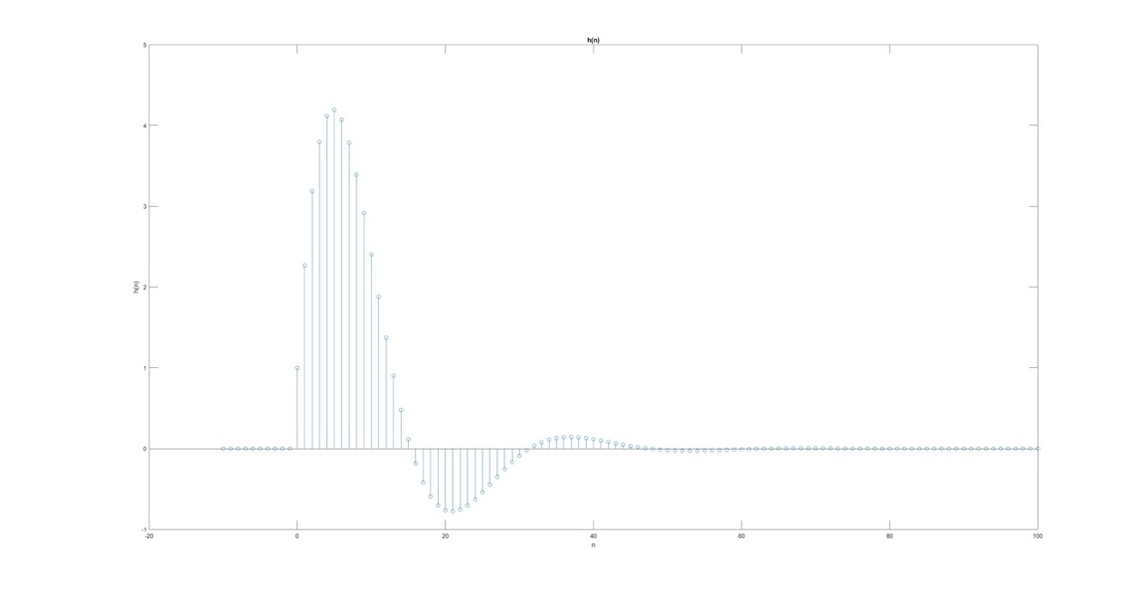

1. Filter

